DEALS TO CAMBRIDGE, MA

Cambridge is an exceptional city just north of Boston and across the Charles River. Named in honor of the University of Cambridge in England, it is home to both Harvard University and Massachusetts Institute of Technology. Book a trip to Cambridge via Boston Logan International Airport on Virgin America. Live it up at 35,000 feet with WiFi, on-demand entertainment, and more on every flight.

(MARKET IMAGE HERE)

Find Deals From These Cities

INSERT FARE GRID FROM / TO Version (if available!)

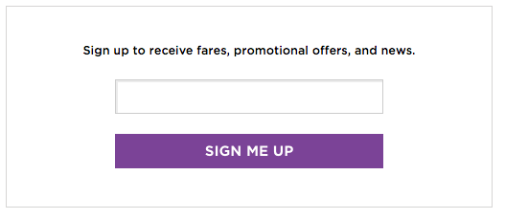

Top Things To Do in Cambridge, MA

When visiting Boston, you can experience a variety of Cambridge attractions, such as charming restaurants, first-rate museums, and a vibrant performing arts scene. Be sure to include the ones below on your list of what to do in Cambridge, MA.

* Explore the impressive collections at the Harvard Art Museums. These three museums, located on Quincy Street, are a part of Harvard University.
* Visit the Fresh Pond Reservation, a park and reservoir in Cambridge. If you’re in the mood to exercise, go for a walk, run, or cycle around the 2.25-mile perimeter road that surrounds the lake. Or, if golf is more on par with your interests, play a round at the nine-hole course.
* Grab a coffee, pastry, salad, or sandwich – or even sign up for a class – at the famous Flour Bakery. The only difficulties will be deciding what to get out of all the delectable items on their menu and, most likely, waiting in a line that’s out the door. But trust us, it’s well worth it.

Travel Tips and Resources

[Must-Dos in Cambridge](http://www.harding-house.com/our-top-10-favorite-things-to-do)

[Cambridge Hotels](http://www.tripadvisor.com/Hotels-g60890-Cambridge_Massachusetts-Hotels.html)

[Cambridge Restaurantshttp://www.tripadvisor.com/Restaurants-g60890-Cambridge_Massachusetts.html](http://www.tripadvisor.com/Restaurants-g60890-Cambridge_Massachusetts.html)

[Cambridge Shopping Guidehttp://www.visitcambridge.org/shopping](http://www.visitcambridge.org/shopping)

[Cambridge Nightlife and Entertainment](http://cambridge.net/us/restaurants-nightlife)

[Cambridge Travel Tips](http://www.fodors.com/world/north-america/usa/massachusetts/boston/neighborhoods/cambridge)

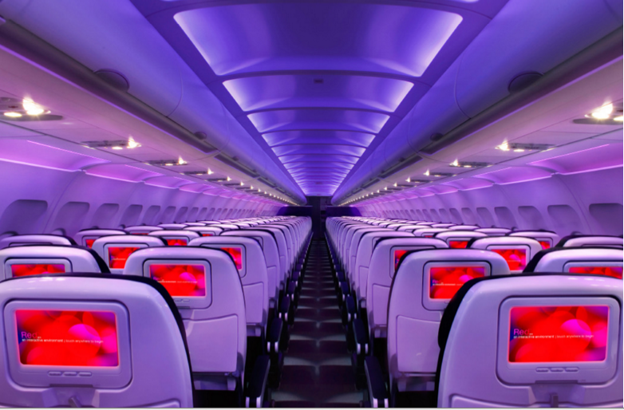

Main Cabin Main Cabin Select First Class

(add links to Cabin Class Pages)

Ready. Set. Fly.

Book your Mood-lit Ride to Cambridge, MA.

When traveling to Cambridge, MA, book your flight to Boston Logan International Airport with Virgin America. Once you land, the center of Cambridge is a short six miles away. We guarantee you’ll love the in-flight experience we provide. With our custom-designed leather seats and mood-lit cabins, you’ll instantly get comfortable. And our many other unique amenities will enable you to fully enjoy your flight.

Take a Virtual Tour

Add Terms & Conditions